Computers were initially developed to solve Arithmetic flipping 0 and 1. In the modern time, Computers are used in a lot more areas like Internet, Wi-Fi Graphics, Artificial Brain, simulating the Universe and many more. To talk about the history of evolution one cannot omit about the size and power of computers. The computing power of a single phone is more than what was there in Mid 1960s. Talking about computer Science can be a bit messy but can be described into three segments: Theoretical computer Science, Computer Engineering and Applications.

Alan Turing was the father of theoretical computer science creating a Turing Machine which a base for any other designs created by other people in generations. The working principle had several parts: Long tape(symbols), Head(Read/Write), State Register (store state of head) and Instructions.

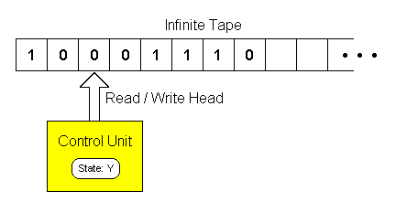

*Fig: Turing Machine working principle*

Computers always cannot solve problems. Halting problem is one example where the computer tries to predict the program will stop running or will carry on forever. These are the problems which can neither be answered by computer or a Human. There are also many problems than can only be solved in a theory but practically is impossible which is categorized by computation complexity. The problems are practically impossible due to the amount of memory and the number of steps required to solve that program. In summary, there are many classes of complexity and classes of problems that fall into these types.

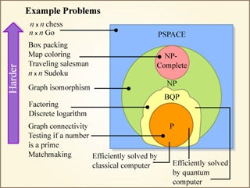 *Fig: Computational Complexity*

The Hardware of the computers do not run on their own. We need a set of instructions independent of programming language which can solve a particular problem, called as Algorithm. Different Algorithms can be used to solve a certain problem but how can we call which algorithm is the best one? We can’t in general but looking at the problem and the time and effort consumed by a certain algorithm while comparing we can definitely say as the best one for a certain problem. This is called as algorithmic complexity.

The information is the processed data and consists of its own properties. Information theory studies those properties and deals with how it can be stored properly and communicate. Its application can be compressing, parity checking and many more. Having the information is not effective if it is not secure, so we use **Cryptography**. There are many encryptions and decryptions ways to keep the information locked up. There are many more theories like Graph Theory, Parallel Programming, DSA (Data Structures) inside Theoretical Computer Science.

Designing a computer can be called as a challenge as computers in today’s generations solve many different kinds of problems. The second segment Computer Engineering falls under it. We play games, listen to music, do assignments simultaneously on a Computer. They are called process and operated by CPU. The scheduler helps maintaining smooth operation by giving access to all the process to the CPU one at a time but we don’t feel the same way and think computer is doing everything at once. It is achieved through effective Computer Engineering and a concept of Multiprocessing helps to speed things up. CPU falls under Computer architecture for a general purpose similarly, GPU for Graphics. To help the hardware run there are many software written by programming language. Generally, programming language is the way of communicating and giving directions to computer about what it should be doing and how it should be done. Programming language has been more friendly to humans than before. Computers cannot understand that code written in a programming language and Compiler helps the computer to understand the code thus, acting as a translator between humans and machine. Compiler has been a major medium

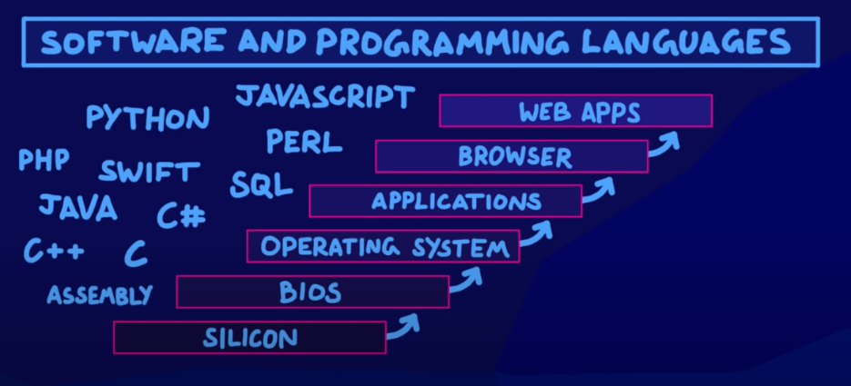for the programmers as it needs to be easy to use as well as versatile enough to build new ideas.

The OS is the platform for the user to run the computer and making computer more user friendly. The needs of good OS need S/w Engineering. Designing a software is the process of designing and translating the crazy ideas that one has into a logical instruction error- free and smooth.

The last segment Application fall under solving real world problems by the computers. If you want to go to a certain destination you would like to get the shortest route i.e. Optimization. Finding the best paths or the combination of the best paths will help save a business time and money. This can be set on the Boolean Satisfiability where we work whether the logic formula could be satisfied or not. Computers now solve the problems which was once thought of insolvable. Artificial Intelligence(AI) has come role in that. To have the ability to think and act both humanly and rationally is when the AI is achieved to the computers. AI is based on Machine Learning: enabling the computer to learn from the large amount of data. Some of the Machine Learning are (Computer Vision, NLP, Knowledge Representation). Hacking is trying to find the weakness in Computer Systems and taking advantage of that weakness without being noticed. So, cryptography helps to overcome that. The application can be seen in VR, AUR, Human Computer Interaction, Robotics and Telepresence.

In Summary, map of Computer Science has various aspect as it is a field that has started from something for a certain purpose but now used for everything and is still being developed. By seeing the growth of Computer in the history we can all say that this technology will have a huge unthinkable impact in the future that will going to surprise everyone.

2.

PG 39 Qn. 13

No, it is not the correct solution to the given problem. It is incorrect because this algorithm only works when all the three numbers x, y and z are different.

Eg:

If x=1

Y=1

Z=2

Then, this algorithm will not work.

Proper Fix:

Step 1. Start and Check if (x>=y) If yes, GOTO step 2, else to Step 3

Step 2. Check if(x>=z) if yes, X is the largest, else Z is largest

Step 3. Check if (y>=z) if yes, Y is largest, else Z is largest and stop

Flowchart:

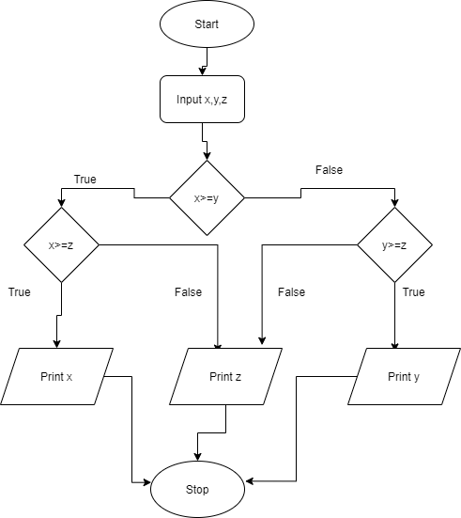

Reference: Flowchart drawn from https://app.diagrams.net/